EFQM EXCELLENCE MODEL AS A FRAMEWORK FOR QUALITY EVALUATION OF CZECH UNIVERSITIES
Jaroslav Nenadál, Milan Hutyra
Ministry of Education, Youth and Sports of Czech Republic,
VSB – Technical University of Ostrava

Abstract:
The Bologna process opened lot of opportunities focused on quality assurance and evaluation also in Czech Republic. Hitherto, quality of any Czech university is evaluated by results through so-called lagging indicators - it means what the university has achieved. The comprehensive quality assessment approach does not examine only what university has achieved in the past, but includes also assessment of university potential for the future through so-called leading indicators. Based on comparative analysis of different assessment methodologies of university quality, the comprehensive methodology for quality assessment of higher education institutions was designed by group of experts in Czech Republic within a special project covered by Ministry of Education, Youth and Sports. The proposed methodology is based on the EFQM Excellence Model framework. The pilot testing of this methodology at selected universities in Czech Republic approved its complexity and suitability last year.
The paper summarizes the principal set of information related to preliminary project results and main lessons learned from methodology pilot testing.
Key words: quality, higher education, comprehensive quality assessment, EFQM Excellence Model, self-assessment.

At first, we must mention three external impacts on serious consideration of the quality in the higher education institutions at Czech Republic:
- participation of our country on Bologna process,
- implementation of European Standards and Guidelines (ESG) elaborated by the European Network for Quality Assurance in Higher Education (ENQA) and
- increasing interest in higher education quality all over the world.
We must not afford to ignore them! But we can also distinguish unquestionable internal factors which ask for university quality assurance and improvement:
- knowledge that quality of universities is not an abstract concept at all,
- students, employers and society concern in good quality of the universities,
- need for effective and efficient university management systems and
- need for comprehensive and objective quality assessment at the universities.
Majority of the Czech universities management have namely realized that there is important difference between study programmes accreditation and comprehensive quality assessment of higher education institutions: mandatory study programmes accreditation is being performed by Accreditation Commission from 1998 (it is stipulated in the Act No. 111/1998) [1]. The study programmes accreditation is mostly based on traditional approach, where only achieved results are evaluated. But overall level of university management system, as well as used quality management tools and enablers are not studied during the accreditation process at all!
That is why, the Ministry of Education, Youth and Sports of Czech Republic has been supporting a special project titled “Quality Assurance and Evaluation in the System of Tertiary Education” from 2010. The principal goal of this project is to develop and verify comprehensive methodology of quality assurance and quality assessment at Czech higher education institutions. There are three key activities within the project. One of them is fully oriented to development and verification of comprehensive quality assessment methodology in area of higher education institutions. Figure 1 depicts proposed comprehensive quality assessment framework at universities as combination of internal and external assessment activities focused on leading, as well as lagging indicators.
To design suitable assessment model which should be accepted by Czech higher education institutions was another task. First of all, we tried to describe basic model of university management system – it is illustrated in figure 2: any university has its interested parties – stakeholders, as customers, university staff (people), representatives of society, environment, etc. They have various needs and expectations and university should fulfil all stakeholders´ requirements by effective and efficient manner. It is supported by university management system, which defines university strategy and policies and uses people and other resources to transform requirements to products and services via set of internal processes. Outputs from processes are results perceived by customers, university staff, society and university as a whole.
Comprehensive quality assessment

Internal quality assessment
External quality assessment
+

Assessment through leading indicators
Assessment through lagging indicators
+

against
Commonly recognized model

Fig. 1: Comprehensive quality assessment framework at universities

Results perceived by customers

University:
- Strategy
- People
- Other resources
- Processes
- Products
- Services

Results perceived by staff

Stakeholders´ needs and expectations

Results perceived by society

Results perceived by university

Fig. 2: Basic model of university management system

Key question was: what are university customers and products? An answer can be found in table 1.

Tab. 1: The main products of university and their customers

Product | Characteristic | Customer | Customer’s expectations
Bachelor,  master and doctoral education | Obtained qualification | Students | Readiness in practice
Bachelor,  master and doctoral education | Obtained qualification | Employers | Performance capability
Bachelor,  master and doctoral education | Obtained qualification | Society | Conformance with development strategy
Life-long learning | Deepen knowledge, change of qualifications | Participants | Possibility to grow, change of career
Life-long learning | Deepen knowledge, change of qualifications | Employers | Planned fulfilment
Scientific, research, development and innovation, art and other creative activities | Looking for a new principles | Society  (enterprises) | New principles, feasibility
Cooperation  with public and business sector | Solving of real problems | Enterprises | Applicable solution, effectiveness

It is clear, the comprehensive quality assessment approach does not examine only what universities achieved in the past, but includes the evaluation of university capability and potential to its further development through so-called leading indicators. They assess the level of overall university management system maturity, its strategy, personnel, resources and partnerships and processes through which all products of university are delivered – it was crucial starting point to search for suitable assessment model. We declared input hypothesis that the most suitable model for comprehensive quality assessment at the universities should be adapted version of the EFQM Excellence Model. Therefore, the evaluation framework according to the EFQM Excellence Model, 2010 version [2] was used as a reference for comparison with other approaches assessing the quality of universities. The EFQM Excellence Model (as assessment framework) was compared to:
- The existing approaches to assessing the quality of universities in the Czech Republic (Accreditation Commission assessment, annual university reports for Ministry of Education, Youth and Sports),
- The methodology developed by ENQA, EUA (SGQA, IEP),
- The generally accepted frameworks for comprehensive quality assessment used throughout the world (CAF, MBNQA),
- The specific approaches of the international evaluation
(EAC for music arts universities, ELIA for dramatic arts universities for example),
- International ranking of universities (CHE Excellence Ranking, ARWU Ranking,
Webometrics, QS Word University Ranging, Times Higher Education Supplement - World University Ranking, ….).
The comparative analysis conduced to ​​the following conclusions:
a) The comprehensive assessment of university quality according to the EFQM Excellence Model includes evaluation of both, the enablers and results of universities.
b) The assessment according to the EFQM Excellence Model is applicable to all types of universities.
c) The RADAR logic as a tool for quantification of assessment, which is inherent part of EFQM Excellence Model framework, minimizes the degree of assessment subjectivity.
d) The using of the EFQM Excellence Model allows mutual comparison of the management system maturity among universities and generates valuable benchlearning.
Based on comparative analysis of different methodologies for assessment of university quality, “The comprehensive methodology of assessment of university quality” was designed by group of experts in Czech Republic. This new methodology is based on the comprehensive model for assessing the quality of university – see Fig 3, which is a modified The EFQM Excellence Model, version 2013 [3], conformed to the universities conditions and environment. We had to adapt primary version of the model as its “original language” was only poorly understood by Czech universities people. A new description of comprehensive model for assessing the university quality concludes following clauses:
- University profile: it is overall description of university organisation and its unique features and products.
- Enablers criteria:
  - Title and definition of main criterion.
  - Titles and guidance points of partial assessment criteria.
  - Terms and definitions.
  - Possible university references.
- Results criteria:
  - Title and definition of main criterion.
  - Titles of partial criteria.
  - List of possible quality indicators to be measured and monitored.
  - Possible information resources (records) within the university.

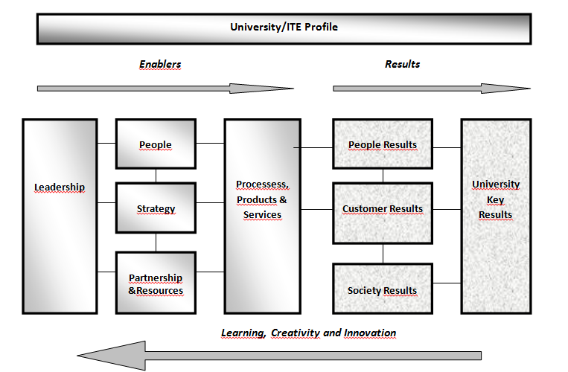

Fig. 3: The comprehensive model for assessing the quality of university
Such description is only one from documented procedures, which were prepared by team of experts to support implementation of the internal quality assessment at Czech universities. There are also available other documents, as:
A) Manuals:
- Glossary of Terms.
- Description of quality assessment criteria.
- Guidelines how to use the quality assessment criteria.
- Methodology of internal quality assessment.
- Guidelines how to prepare internal assessment report.

B) Tools:
- E-questionnaire for the first internal assessment.
- E-forms for detailed internal assessment.
The pilot testing of the comprehensive methodology of university quality assessment supported by the research team of experts was performed at 11 selected Czech higher education institutions last year. Internal quality assessment against the comprehensive model was performed by internal assessor teams to discover strengths and especially areas for next university improvement. Internal assessment reports served as:
- documents for university top management decisions makings focused on necessary changes or improvements at universities,
- set of information needed during the external quality assessment. It was provided by assessor teams created by Czech Society for Quality on January and February 2013.
The pilot testing of the comprehensive methodology for assessment of university quality brought more than 400 notes and recommendations. More than 260 were accepted by team of experts to make the methodology more comfortable and easier to use. But the pilot testing brought also lot of very interesting lessons learned. Let us mention some of them:
- All universities accepted the designed concept of comprehensive quality assessment. It is fundamental finding indeed!
- Customer orientation principle was not easy to accept for important part of university staff from the beginning.
- The proposed assessment criteria as well as methodology of internal quality assessment seemed to be rather complicated for important part of university people.
- Special training of assessor teams (created from universities staff) is necessary to deeply understand assessment criteria and methodology as a whole.
- Identified weaknesses were mostly understood as a chance for next improvement of processes at the universities.
- External assessors unfortunately had only limited experience related to the university processes and products – it led to the frequent mutual misunderstanding between these assessors and university staff during external assessment.
- Absence of data from benchmarking was discovered as the most frequent weakness in all higher education institutions engaged in the pilot testing.
- Well established system for career development was identified as the most frequent strength.
All lessons learned serve as valuable inputs to the preliminary project outputs modification and improvement. Modified methodology of comprehensive assessment of university quality will be reviewed by international experts this year and then all project results will be handed to the Ministry of Education, Youth and Sports of Czech Republic. While proposed external quality assessment depends on The Higher Education Act revision, the internal quality assessment can be used immediately at each of Czech higher education institution! We are sure such internal quality assessment could be powerful approach to the next universities development and continuous improvement or necessary changes.
As quality of education is basis of all other qualities!
Acknowledgements
This paper was prepared with support of IPN No. CZ.1.07/4.1.00/22.0001 "Providing and evaluating quality in the system of tertiary education".

References:
[1] KOHOUTEK, J.: Studies on Higher Education. Implementation of the Standards and Guidelines for Quality Assurance in Higher Education in the central and East-European Countries – Agenda Ahead. Bucharest. UNESCO - CEPES. 2009, 321 p. (ISBN 92-9069-189-2)
[2] EFQM Excellence Model 2010. Brussels. EFQM. 2009, 32 p. (ISBN 90-5236-483-4)
[3] EFQM Excellence Model 2013. Brussels. EFQM. 2012, 34 p. (ISBN 978-90-5236-670-8)

